1) [When *Mapping the Shadows of New York City*](http://www.nytimes.com/interactive/2016/12/21/upshot/Mapping-the-Shadows-of-New-York-City.html?_r=1) - New York Times

When *Mapping the Shadows of New York City* was first tweeted by the [@NYTGraphics](https://twitter.com/nytgraphics?ref_src=twsrc%5Egoogle%7Ctwcamp%5Eserp%7Ctwgr%5Eauthor) account, my immediate reaction was: “What on earth is this?” Then I clicked on it and my thought process was something like: “Oh. My. God. This is the most beautiful thing I have ever seen.”



OK, perhaps there are some real-life things that are more beautiful - my mum (have to), Niagara Falls, CN Tower - but as graphics go, this was, and is, spectacular.

Everything about this piece by [Quoctrung Bui](http://quoctrungbui.com/) and [Jeremy White](http://blueshirt.com/) is novel: the cartography, words, tooltips, heck even the idea is out of left field.

Who knew shadows could have such an impact on a city’s “character and rhythm”, controlling “the flow of foot traffic” and activity on the streets.

Anyway, I won’t spoil it. Enjoy some real-life magic.

2) [Who Will Swing the States](http://www.wsj.com/graphics/elections/2016/swing-the-swing-states-to-see-if-hillary-clinton-or-donald-trump-will-win/?mod=e2twg) - Wall Street Journal

This piece by [Randy Yeip](https://twitter.com/RandyYeipWSJ), [Julia Wolfe](https://twitter.com/juruwolfe?ref_src=twsrc%5Egoogle%7Ctwcamp%5Eserp%7Ctwgr%5Eauthor) and Jessica Ma is another beast of an interactive. Now I know prediction and hypotheticals came into question after most of us got the election result wrong, but *Who Will Swing the Swing States* will still occupy you for hours. Ok maybe not hours, but a very long time.

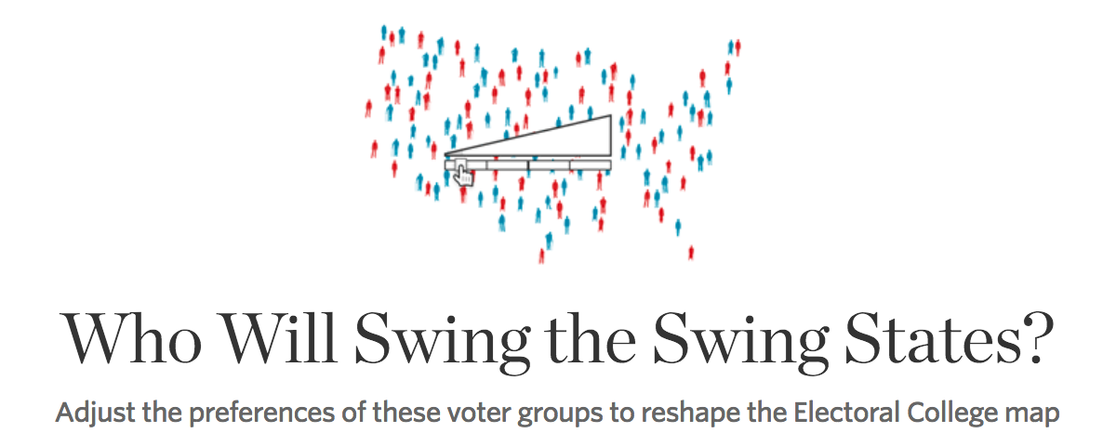

What I love most about this interactive is that there really isn’t much that needs to be explained in the form of words. It’s aesthetically very appealing, and follows the number one rule: it is self-explanatory.

Though the election has passed, you should still indulge in this piece of greatness.

3) [Raising Barriers](https://www.washingtonpost.com/graphics/world/border-barriers/global-illegal-immigration-prevention/) - Washington Post

The multi-format pieces are nothing new, but I’ve never seen something so touching, complex-made-simple piece of journalism as this one.

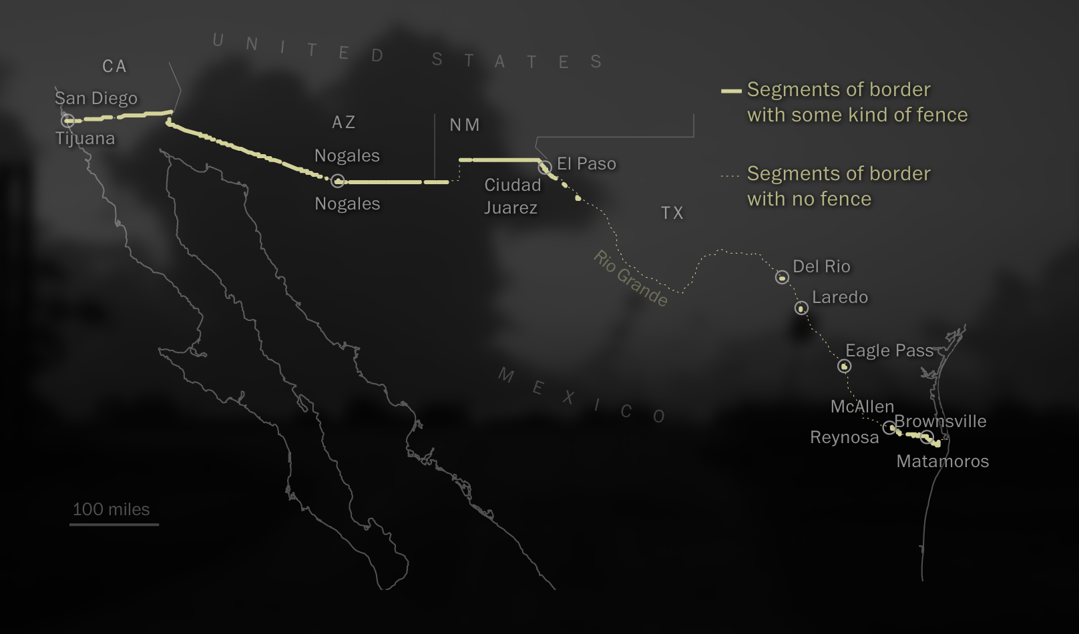

This three-episode piece by [Samuel Granados](https://daniel-levitt-5e7s.squarespace.com/blog/2016/12/29/my-top-10-graphics-of-2016), [Zoeann Murphy](https://daniel-levitt-5e7s.squarespace.com/blog/2016/12/29/my-top-10-graphics-of-2016), [Kevin Schaul](https://daniel-levitt-5e7s.squarespace.com/blog/2016/12/29/my-top-10-graphics-of-2016) and [Anthony Faiola](https://daniel-levitt-5e7s.squarespace.com/blog/2016/12/29/my-top-10-graphics-of-2016), has everything: interactivity, graphics, video, sound and people. I can’t quite put how complete it is, so I’ll let you just explore for yourself.

4) [The World In Ten Blocks](http://www.theglobeandmail.com/news/toronto/the-world-in-ten-blocks/article33004612/#1?latest) - Globe and Mail

Holy crap. This blew my mind. Not only do the G & M detail part of my favorite city, you feel like you’re actually walking the 10 blocks in question.



But it does so much more than just explore the Bloorcourt neighborhood. It takes you in and out of the lives of the people that makeup one of the world’s most diverse cities. And what is journalism for? To learn, and with this piece you absolutely do so.

5) [Global Technology Tracker](https://www.bloomberg.com/graphics/global-technology-companies/) - Bloomberg

Another masterpiece by the Bloomberg team. The level of interactivity on this is insane. Line charts, flip cards and data, data, data mean the user is occupied for ever.

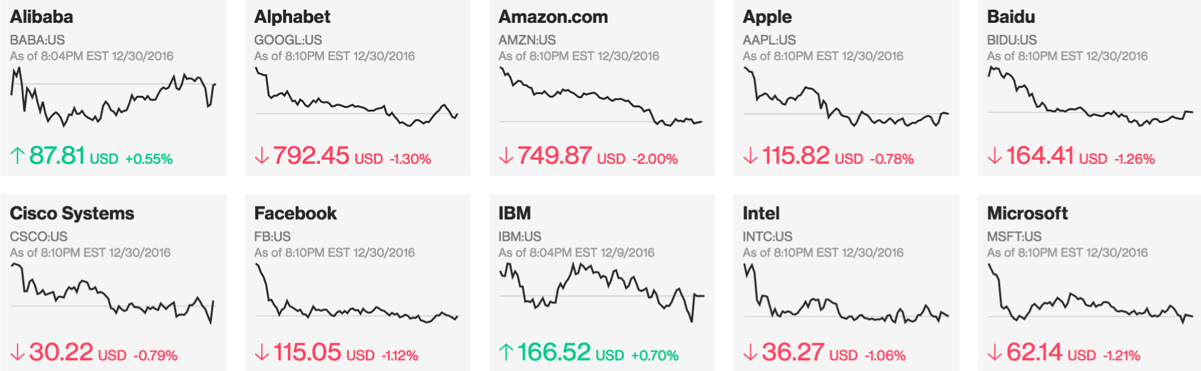

But what I love in particular about this one by [Julian Burgess](https://twitter.com/aubergene?lang=en), [Christopher Cannon](http://christophercannon.net/), [Brittany Harris](http://brittany-harris.com/), Brenda Zysman and [Michael Keller](http://mhkeller.com/), is I didn’t have to think once about what information was being presented to me. As great, and hard, as code is, it’s meaningless unless legible. The team do a great job with this.

6) [2016 Election Forecast](https://projects.fivethirtyeight.com/2016-election-forecast/) - Five Thirty Eight

I had to make room for the url that probably everyone reading this checked at least once during the election season. Nate Silver’s crew created the go-to hub for information and predictions on the election that I checked maybe a dozen times a day.

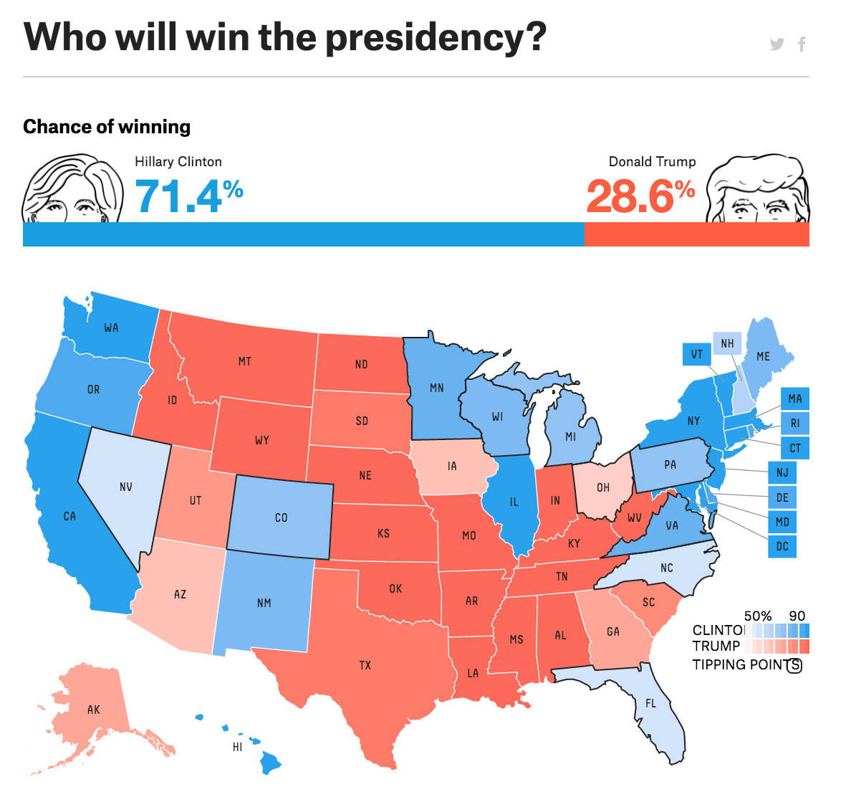

Now it turns out the 538 model wasn’t 100% accurate. But who was? Still, the easiness, depth of information and overall package was unbeatable. Kudos.

7) [Every shot Kobe Bryant ever took](http://graphics.latimes.com/kobe-every-shot-ever/) - Los Angeles Times

I remember when the LAT dropped this. Twitter went nuts. And rightly so. This is any NBA fan’s dream.

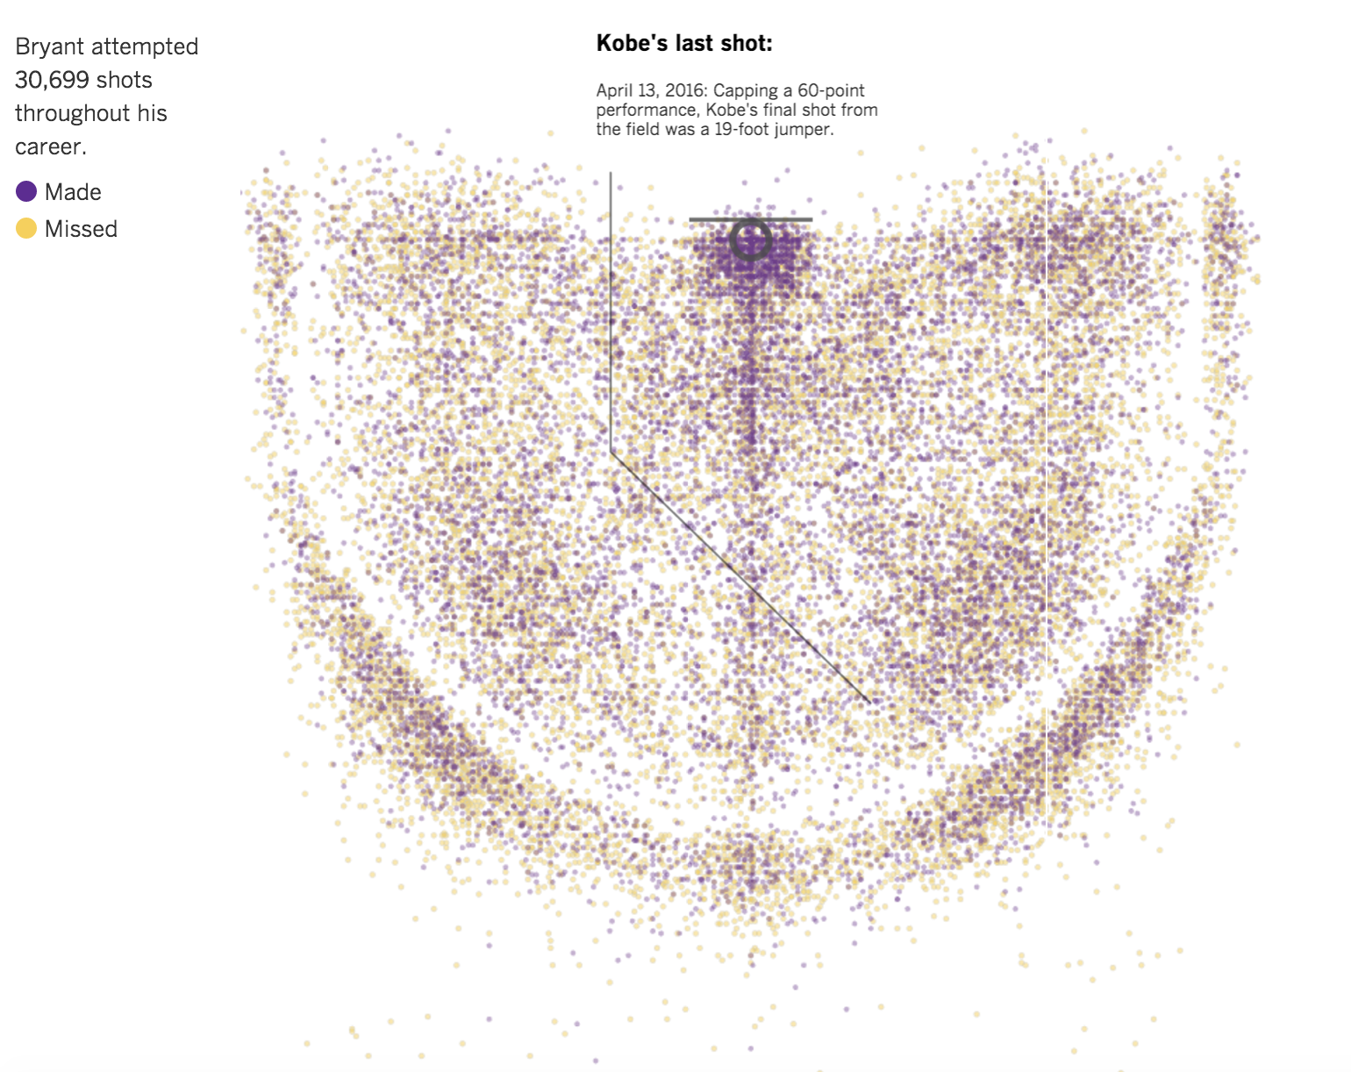

But it also illustrates a level of excellence with certain tools rarely seen in this sphere. I was pleasantly surprised to learn that the project was built primarily using CartoDB. With great comprehension of R and UX, [Ryan Menezes](https://twitter.com/ryanvmenezes?lang=en), [Joe Fox](http://www.latimes.com/la-bio-joe-fox-staff.html) and [Armand Emamdjomeh](http://emamd.net/) pulled off a masterpiece.

[How they created the project](http://www.latimes.com/visuals/graphics/la-g-kobe-how-we-did-it-20160419-snap-htmlstory.html).

8) [Afghan Waste](https://projects.propublica.org/graphics/afghan) - Pro Publica

This is ridiculous. Going back one last time to this one, I totally didn’t even see the bucket load of info and graphics below the interactive app. Sneaky.

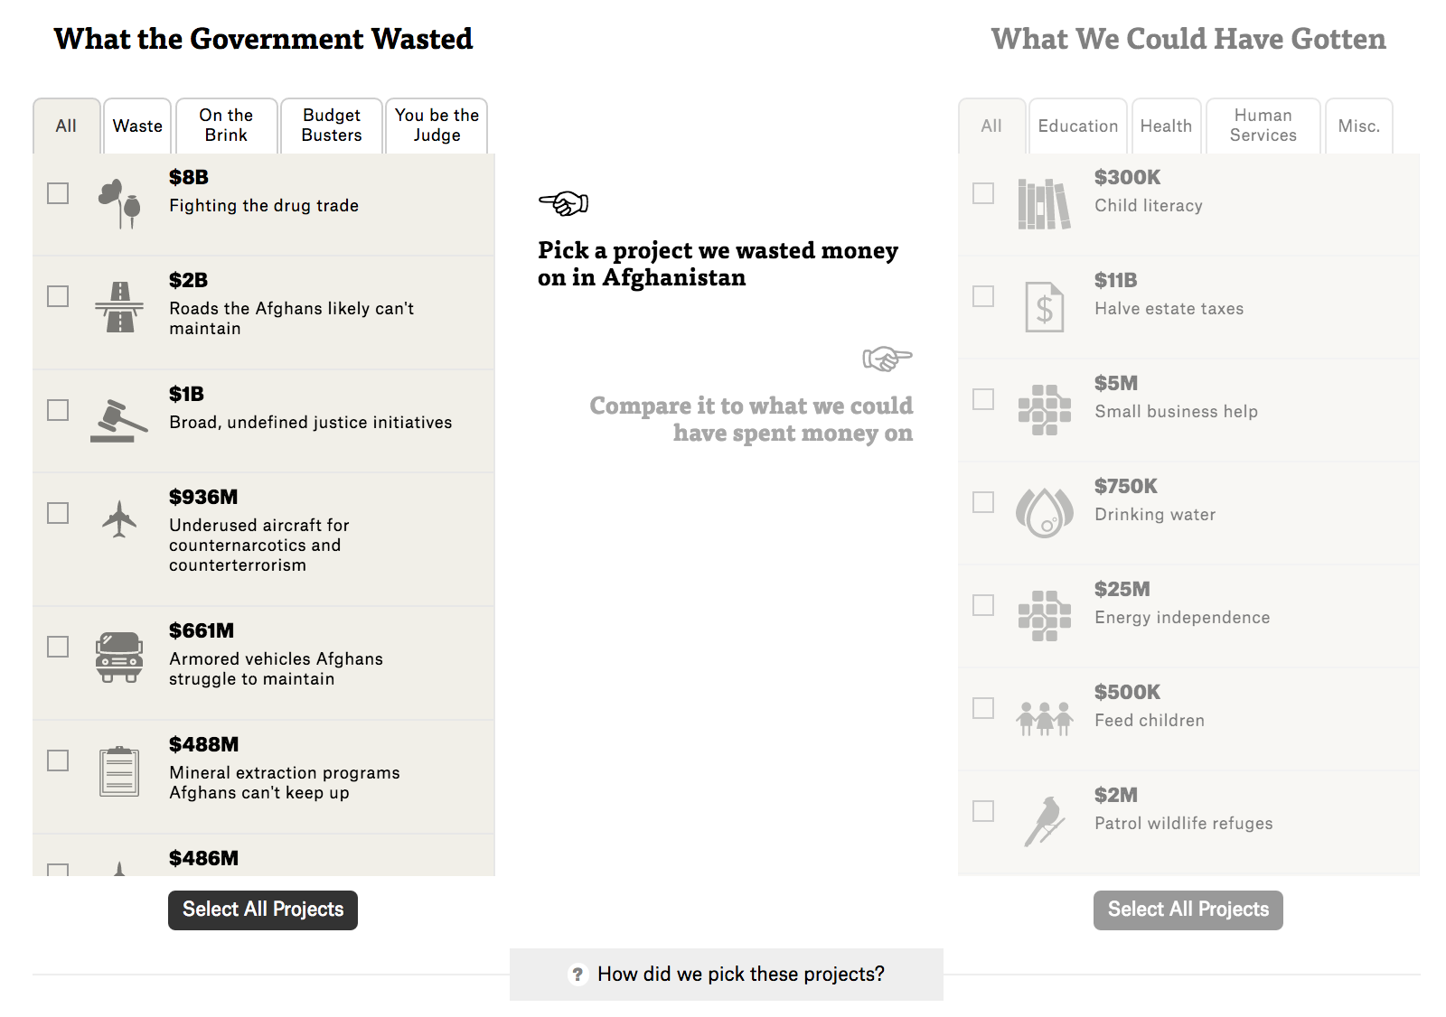

Anyway, this is another gem by [Megan Rose](https://www.propublica.org/site/author/megan_mccloskey), [Tobin Asher](https://www.linkedin.com/in/tobin-asher-858b038a), [Lena Groeger](https://www.propublica.org/site/author/lena_groeger) and [Sisi Wei](https://www.propublica.org/site/author/sisi_wei), whose service to the public simply cannot be overstated. I got lost in making decision after decision, it felt almost like picking a team in basketball. But then you’re quickly reminded that this ain’t no sport, it’s real life and so is the amount of money that was wasted in Afghanistan. A fabulous piece.

9) [Why Americans Don't Vote](https://www.bloomberg.com/politics/graphics/2016-non-voters/) - Bloomberg

D3! D3! D3!

This is anyone’s D3 dream: bright colors, legibility and customizability. D3 is king.

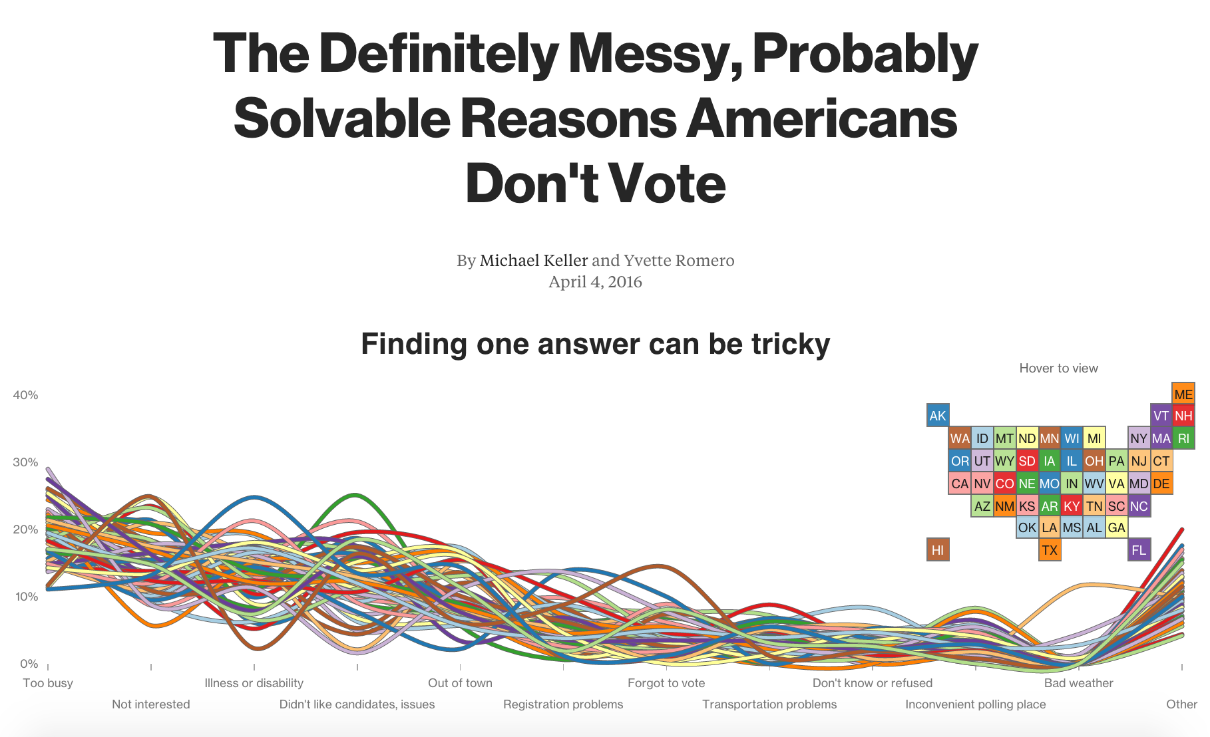

But what I love the most is the design concept: making untangling the most complex issue of the time a lot simpler. [Michael Keller](https://twitter.com/mhkeller?ref_src=twsrc%5Egoogle%7Ctwcamp%5Eserp%7Ctwgr%5Eauthor) and Yvette Romero do a terrific job with this one.

10) [Fatal Force](https://www.washingtonpost.com/graphics/national/police-shootings-2016/) - Washington Post

The WaPo has owned the issue of police brutality since it broke out a few years back. So many publications try to do too much with this issue, which isn’t the worst thing to attempt, but the Post do all that is needed. A fine end to a list of incredible graphics for 2016.

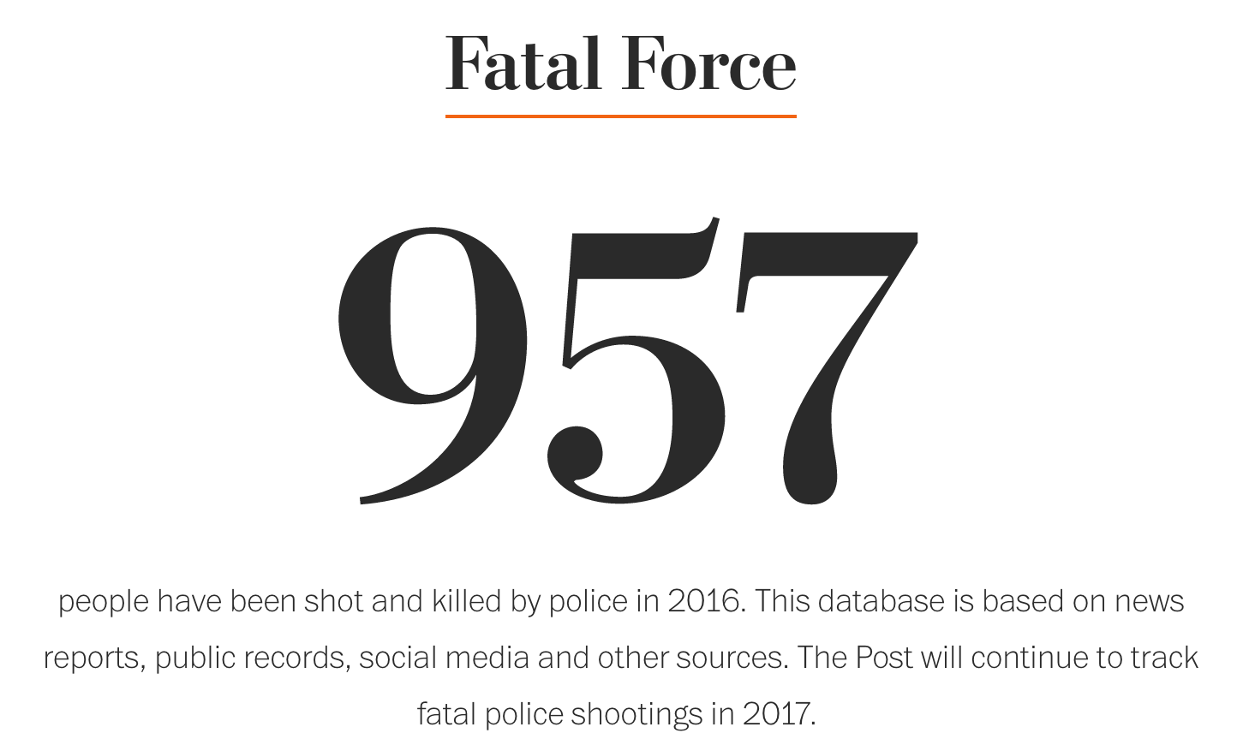

December 31, 2016